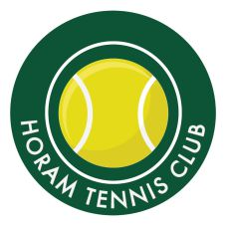
HTC TERM TIME SUMMER COACHING TIMETABLE
0900  1000 | MONDAY | TUESDAY | WEDNESDAY | THURSDAY | FRIDAY | SATURDAY | SUNDAY
 | Cardio Tennis  9.30-10.30am |  |  |  | Rusty Racquets  9am – 10am | Red Ball  4-7  9am - 10am
 |  | Adult Social Tennis  10am -12pm |  | Adult Social Tennis  10am -12pm | Adult Social Tennis  10am -12pm | Orange & Green Ball 8-11  10am - 11am
1100 |  |  |  |  |  | Yellow ball
1200 |  |  |  |  |  | 11am-12pm
1300
1400
1500
1600 |  | Red &Orange  Ball 4pm-5pm  11-16 Yellow Ball Group  5pm-6pm | Orange/Green Squad 8-11  5pm-6pm
1700 |  |  |  | Cardio Tennis  7pm-8pm
1800 |  |  | Yellow Ball Development Squad  6pm-7pm
1900
2000

